Outputs of Test SQLs

Table-create-drop: none

Table-select-0:

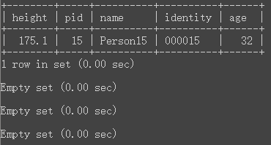

Table-select-1:

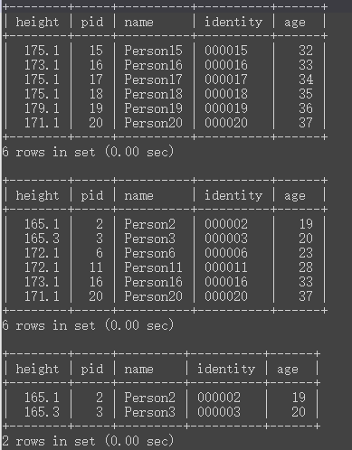

Table-insert-delete-0:

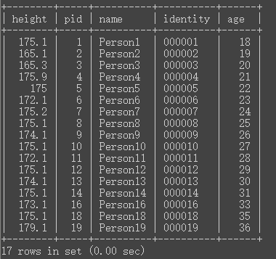

Table-insert-delete-1:

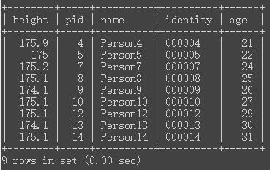

Index-create-delete-0/2: none

Index-create-delete-1:

